Figure 1 Initial condition*:* Add one cell of type NORMAL (as opposed to METANEPHRIC or ATTRACTIVE) and subType END (color: cyan). Update the simulation one step at a time as directed from the GUI (maximum of "iter" currently equal to 30).

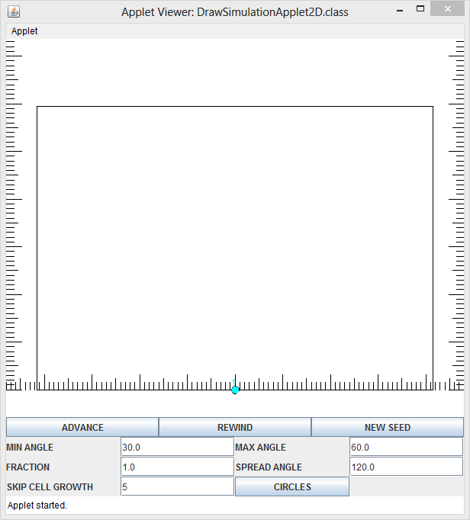

Figure 2: The second cell is constructed one unit above the initial cell.

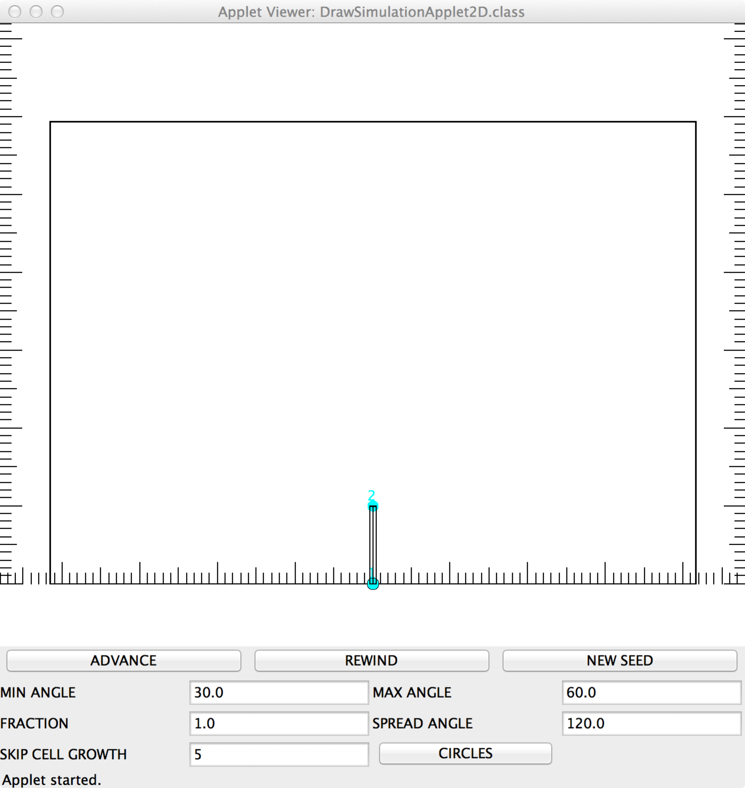

Figure 3: The initial metanephric (positions generated randomly) and attractive cells (fixed) appear. The metanephric cells (initially blue) are updated each step, the attractive cells (magenta) are stationary, every "SKIP_CELL_GROWTH_STEPS", update the normal cells. In this examples SKIP_CELL_GROWTH_STEPS is equal to 5. In the following figures, only the steps where the “normal” cells are grown are shown (note that normal cells do not move once they appear).

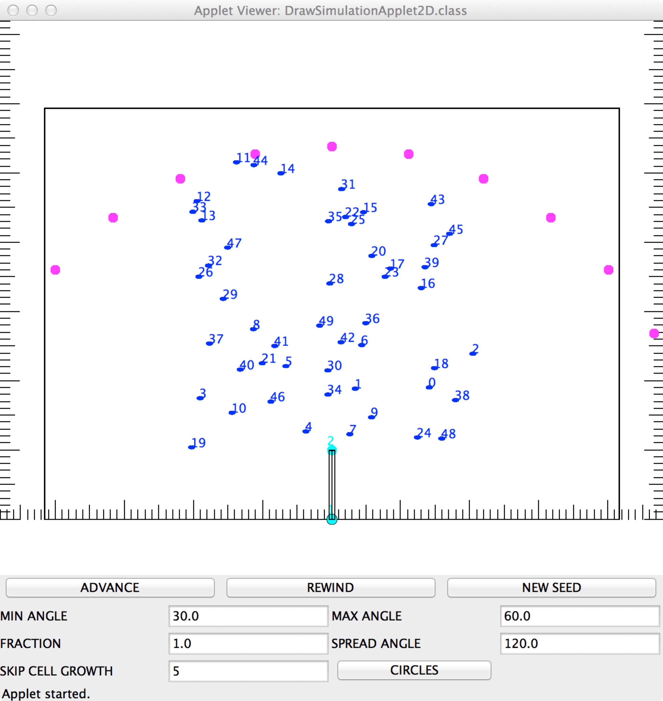

Figure 4 Two more new normal cells are constructed (that is without random generation of coordinates), each one 60° to either side of the main “trunk”. The color red indicates the cells at the end of the left and right main branches.

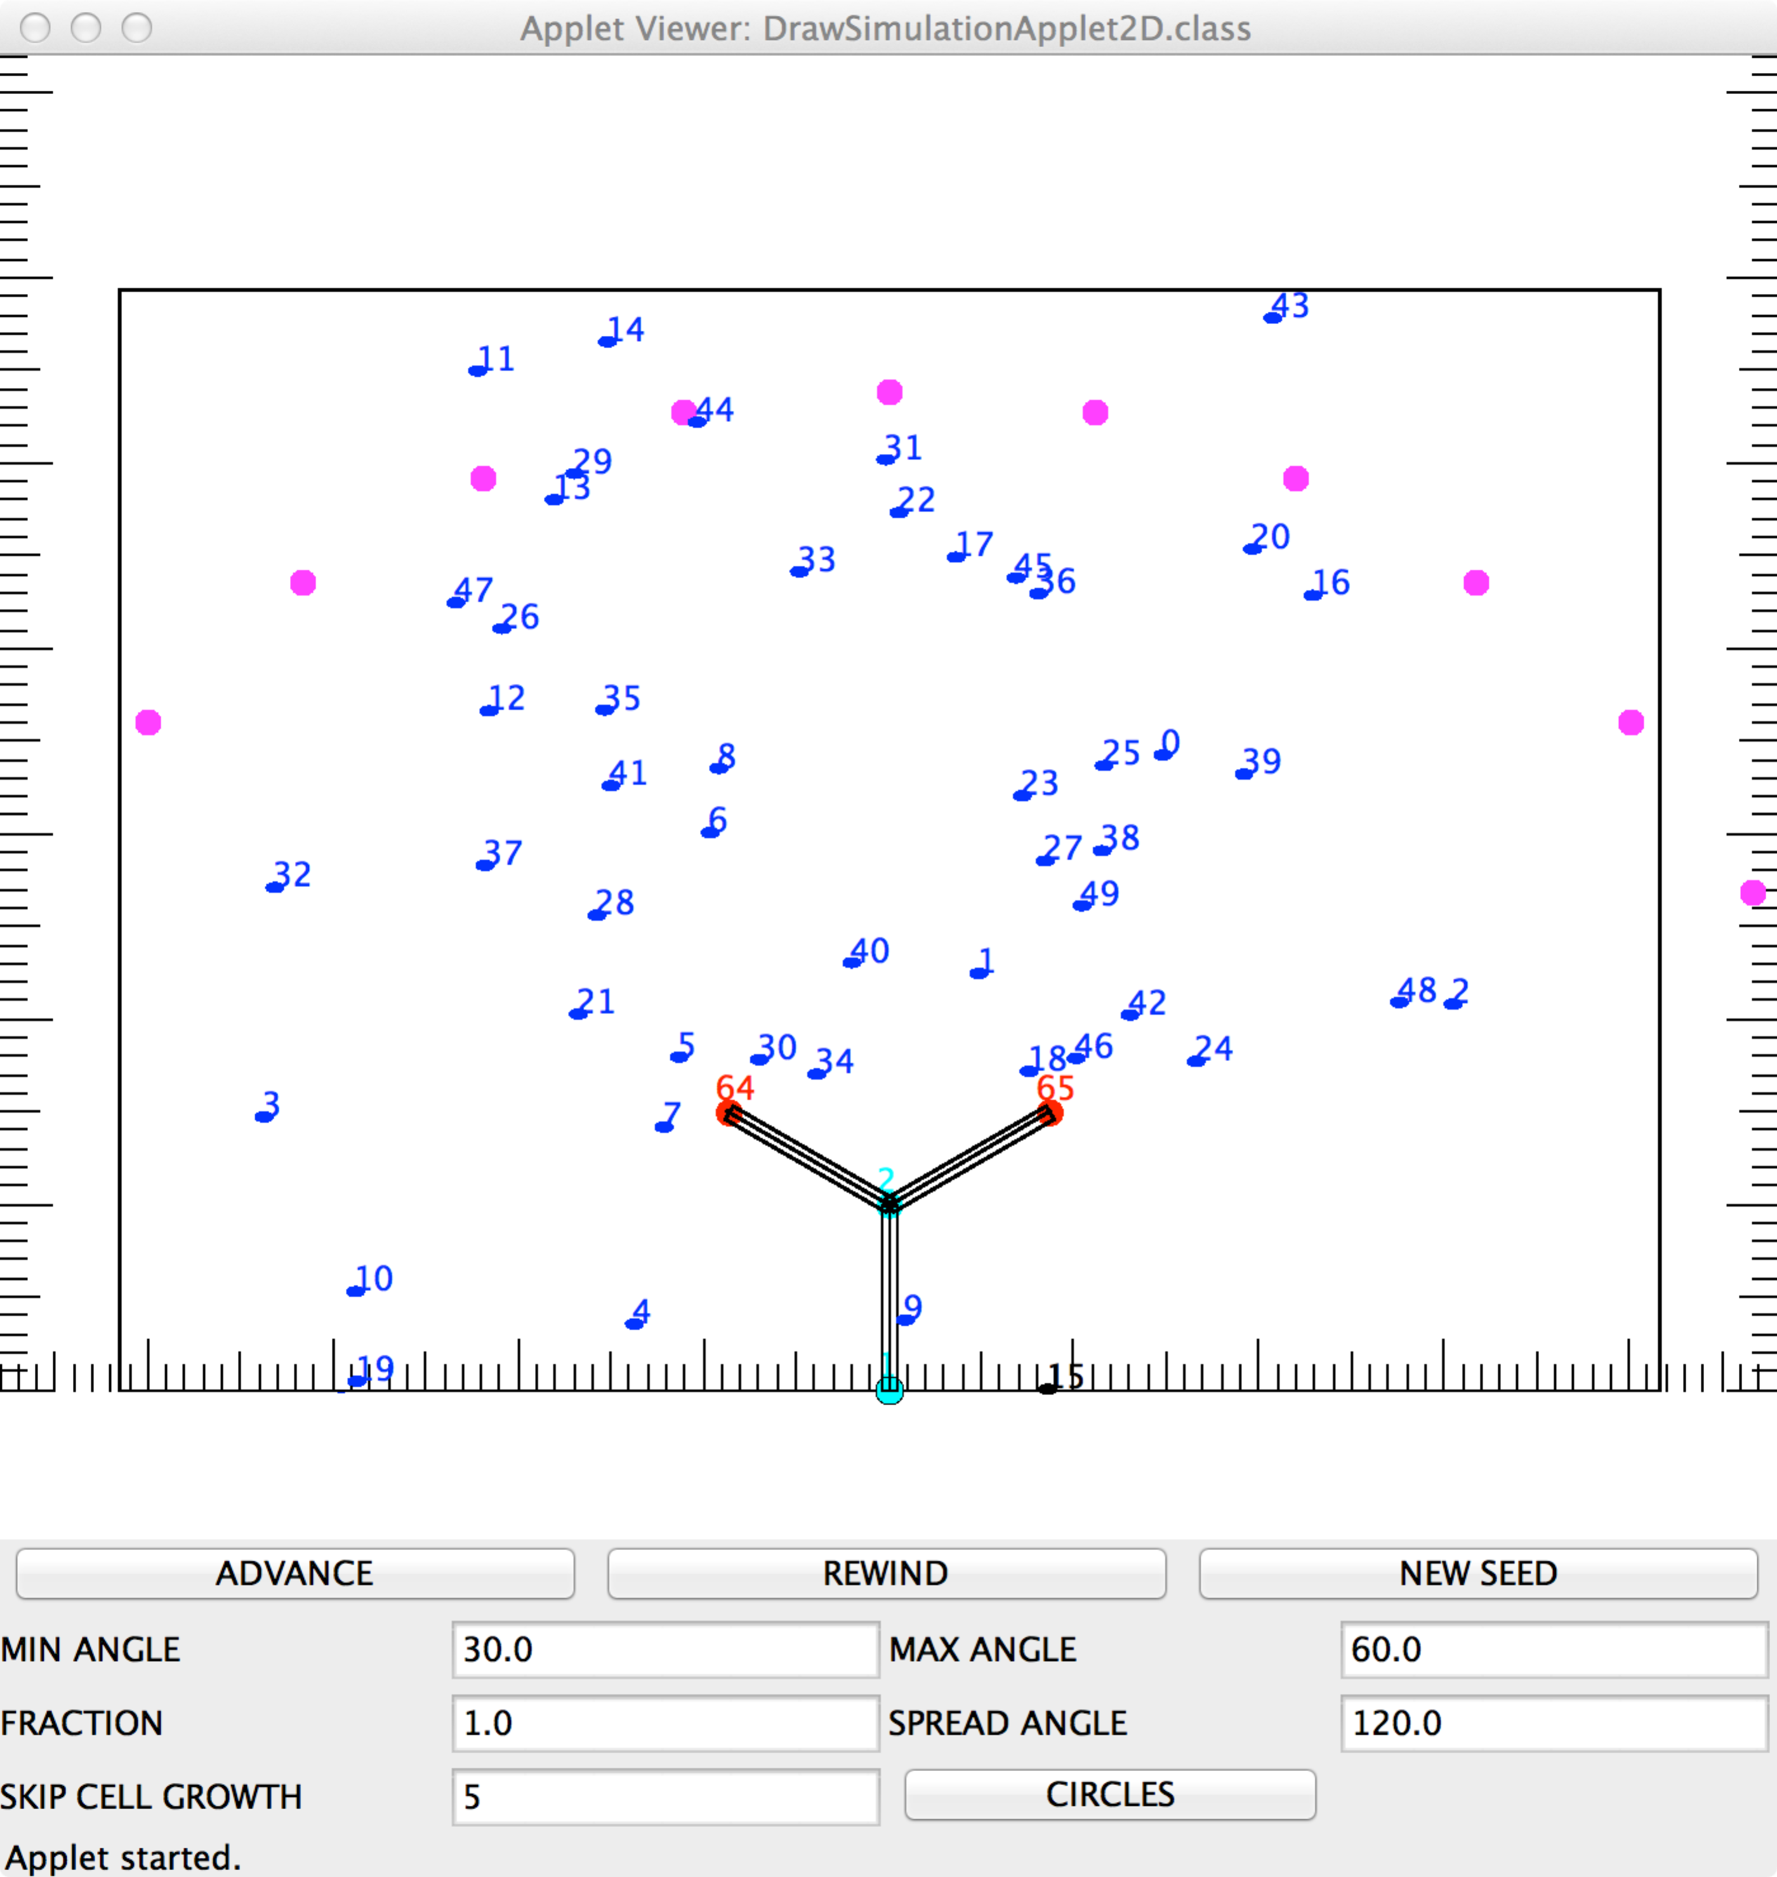

Figure 5: First randomly generated coordinates of new normal cells. The previous red cells are now colored green indicating that they are on one of the two main branches, but not on the ends. There is a maximum of new cells that can grow from each old cell (currently set to 2). The angle of the new cell relative to the parent cell is determinied randomly and the range of random angle depends on whether or not the parent cell is on the main branch. The black color on the metanephric cells indicates that that particular cell crossed a periodic boundary. Each time a cell crosses a periodic boundary, it toggles between black and blue.

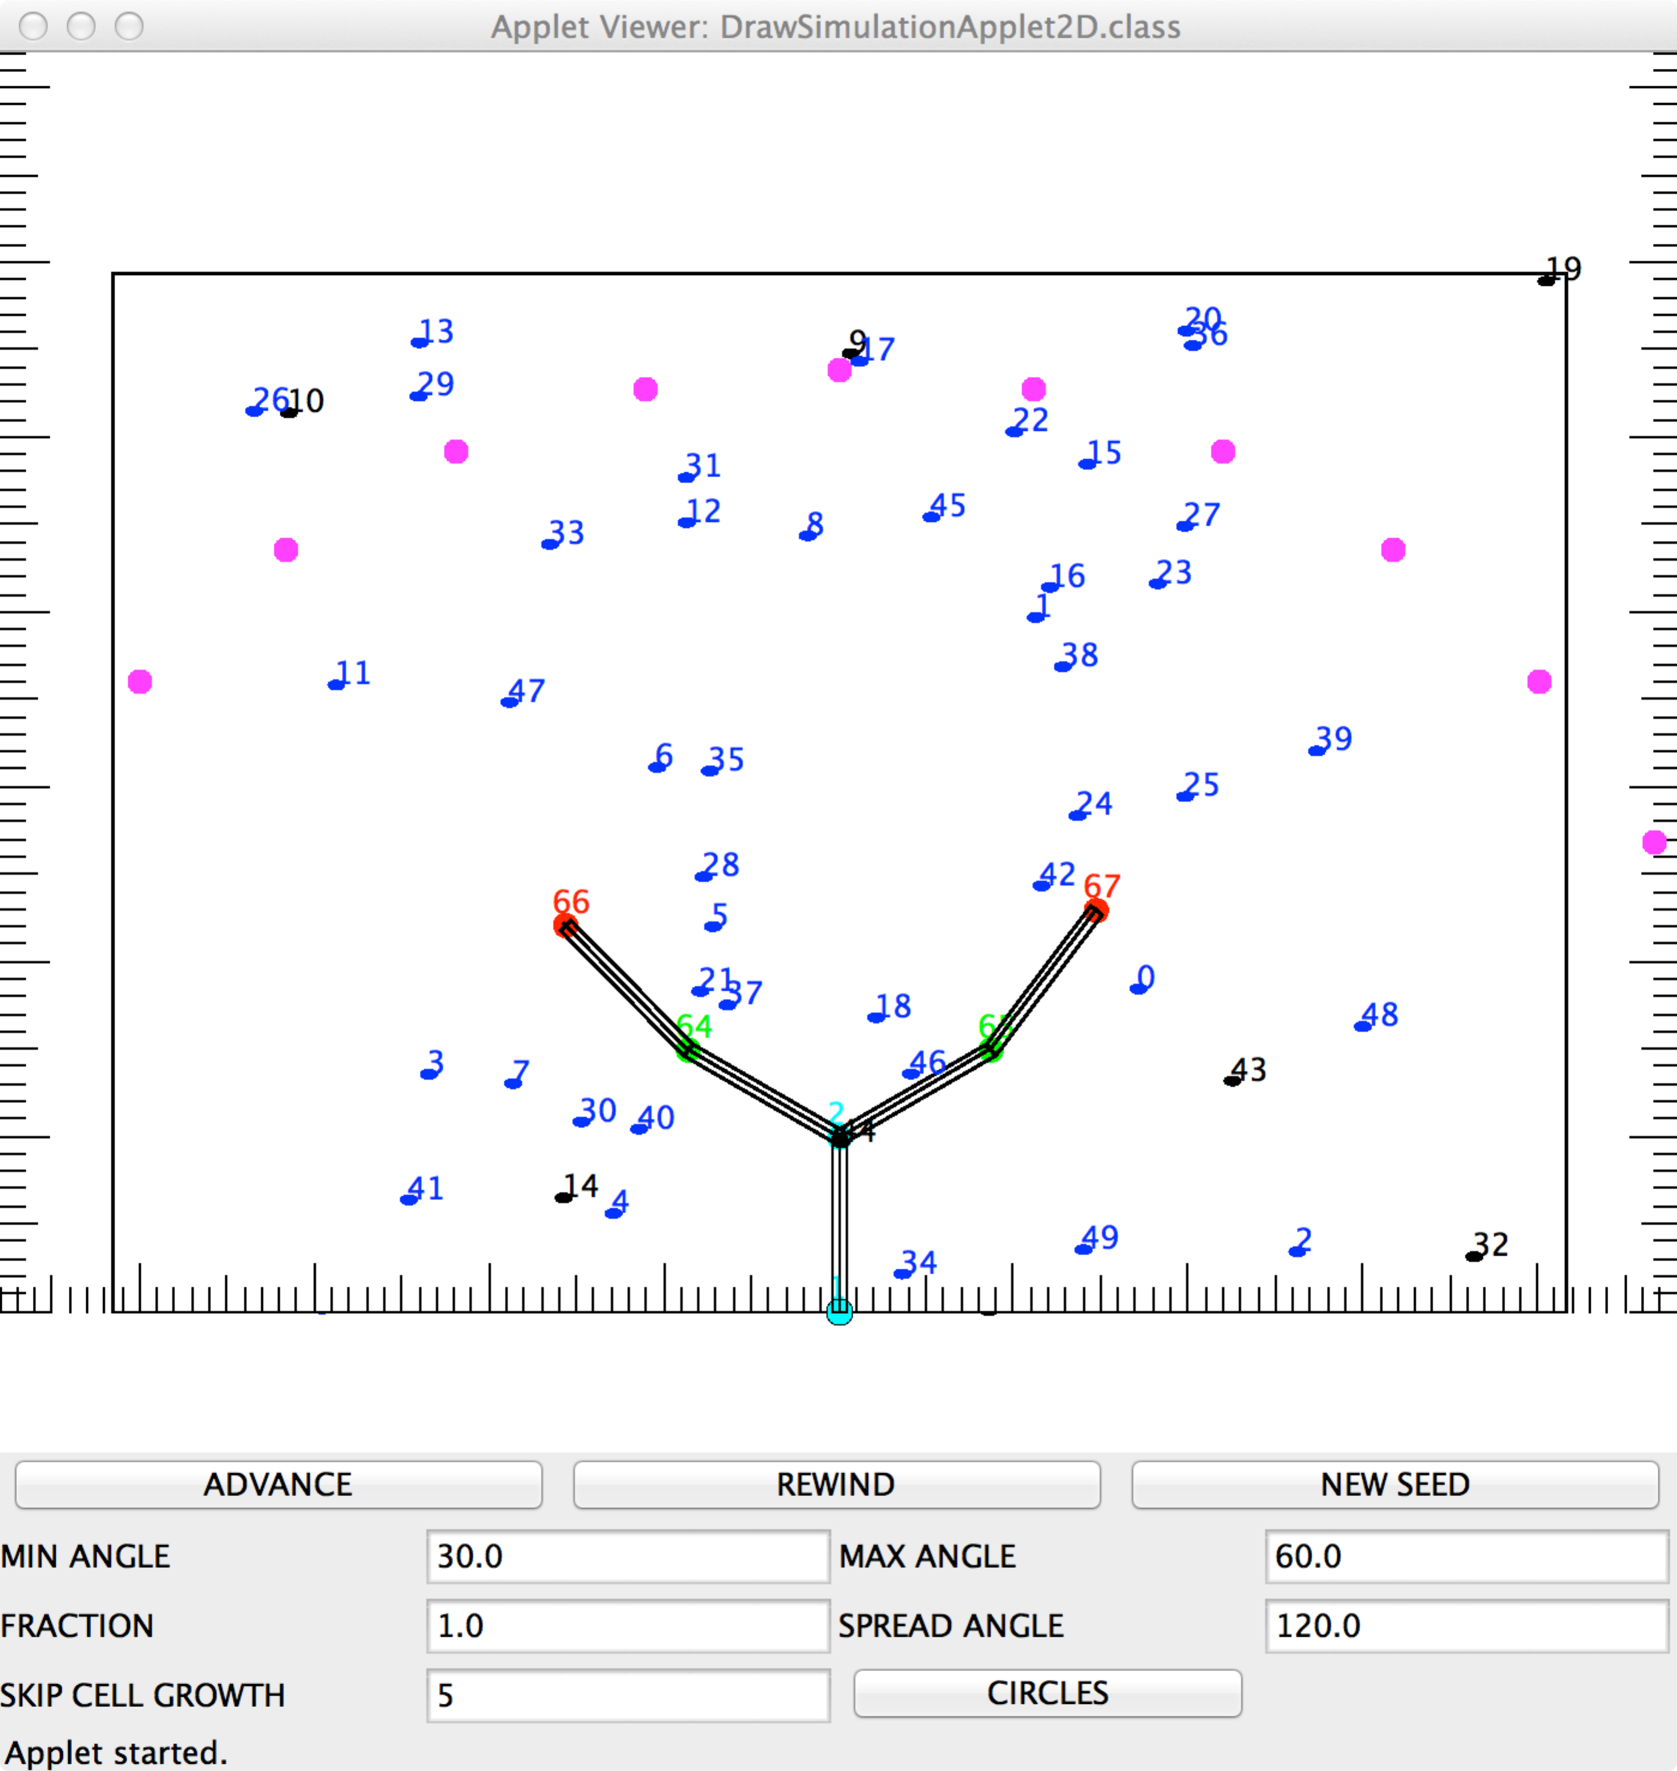

Figure 6 Here, new normal cells have grown off the main branch. Since they are not part of the main branches, they are colored cyan.

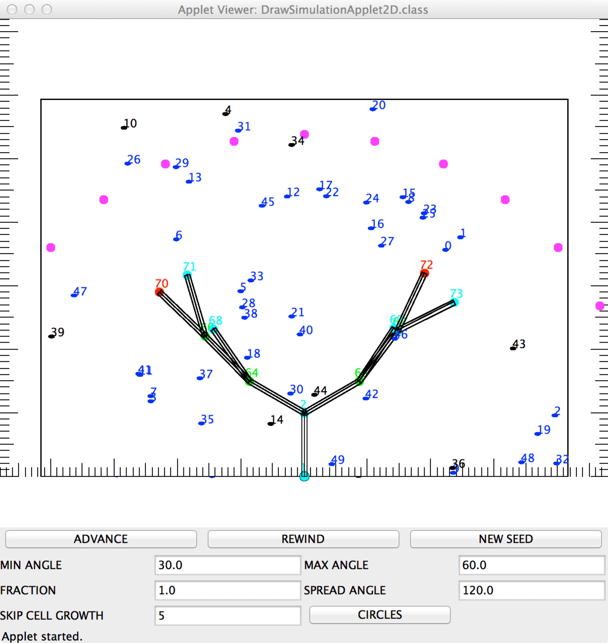

Figure 7 The previous end cells are now colored yellow indicating that they are not part of one of the two main branches and are no longer end cells

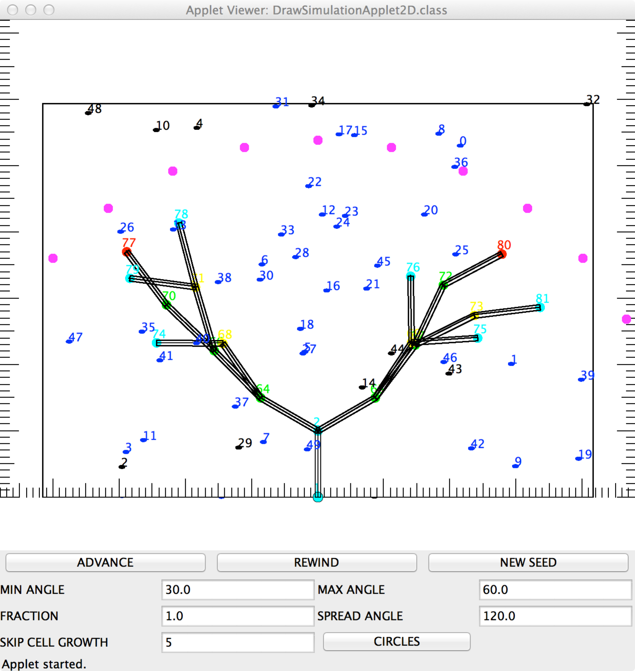

Figure 8 On the last update of normal cells, grow cells of subtype “LAST” which attract the metanephric cells. (Note that if it is calculated that a new cell is beyond the semi-circle formed by the attractive cells, it is discarded: hence the end cells of the two main branches (colored red) are not shown). A vector from each metanephric cell to the nearest LAST cell is calculated, a small random angle is added on, and the metanephric cell is moved along this vector by 0.1 units.

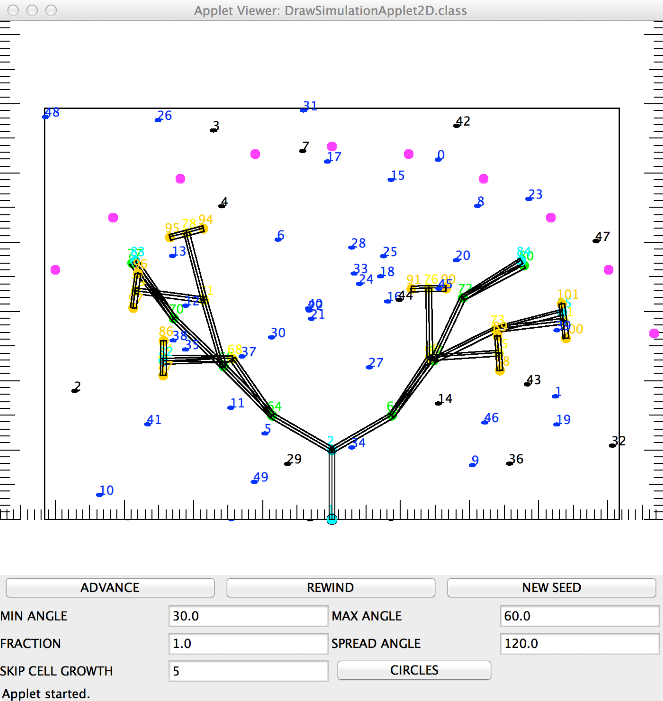

Figure 9: The last update of the metanephric cells. The metanephric cells, due to the attraction of the “last” normal cells, migrate towards them until they are either bound to a “last” cell or bound to another metanephric cell that is already bound to a normal cell (bound metanephric cells colored gray). Each time a metanephric cell is bound a new one is created with random coordinates (red)

